***Mohanlal Sukhadiya University***

*(University College Of Science)*



Project Report

Bca 5th Semester

Section ‘B’

Topic = “ City – Tour”

Submitted to : Submitted by :

Mr. Jitesh Kumar sir Hans Patel

# *Declaration*

I here by declare that the work which is being presented in the project On “City-Tour Web-Site ”

This website develop for helping people for booking tours packages .

Our website ask to customer where they want house and how much there buegdt is how much room they required

# *Acknowledgment*

It is an honor for me to thank all those people who made this thesis possible. I want to thank my advisor. This would not be possible without their help and support.

I also want to thank all my faculties (Mr. Jitesh Sir)and friend for their constant help throughout the whole time. I could not have done it without their help.

|  |  |
| --- | --- |
| 1 | *Declaration* |
| 2 | Acknowledgement |
| 3 | Introduction |
| 4 | Abstract |
| 5 | Overall Description |
| 6 | Aim And Object |
| 7 | System Analysis |
| 8 | Feasibility Study |
| 9 | Configuration |
| 10 | Technology used |
| 11 | Used Module |
| 12 | Scope And purpose |
| 13 | Design Phase |
| 14 | Technology Overview |
| 15 | Creating database And Inserting Data |
| 16 | Admin Page |
| 17 | Bibliography |

## INTRODUCTION

The “City Tour” Travel Management System is a web based application. The main purpose of “ CityTour” travels management system is to provide a convenient way for a customer to book hotels, flight, train and bus for tour purposes. The objective of this project is to develop a system that automates the processes and activities of a travel agency. In this project, We will make an easier task of searching places and for booking train, flight or bus. . In the present system a customer has to approach various agencies to find details of places and to book tickets.

## Abstract

The objective of the project is to develop a system that automates the processes and activities of a travel and. The purpose is to design a system using which one can perform all operations related to traveling.

**OVERALL DESCRIPTION 1 Product Perspective** :

The website City Tour aimed towards recording a considerable number of booking records and needs online assistance for managing records of packages. Website should be user-friendly, ‘quick to learn’ and reliable website for the above purpose. CityTour is intended to be a stand-alone product and should not depend on the availability of other website. The system will also have an administrator who has full-fledged rights with regards to performing all actions related to control and management of the website.

1. **Product Functions** :

There are two different users who will be using this product:

* + Administrator who can view and edit the details of any package.
  + customers who can view their details as well as they can edit their details. The features that are available to the Administrator are:
  + An Administrator can login into the system and perform any of the available operations.
  + Can enable/disable paqckages information
  + Can edit package information to the database.
  + Can make search for a specific package details.
  + Can access all the details of the packages.
  + The features that are available to the packages are:
  + Student can login into the system and can perform any of the available options.
  + Can edit package personal details Can upload packages image.

1. **User Classes and Characteristics :**

There are mainly two kinds of users for the product.

The users include:

* + Administrator
  + Customer

1. **Operating Environment :**

The product can run on any browser.

1. **Constraints :** 
   * Every user must be comfortable using computer.
   * All operations are in English so user must have basic knowledge of English

## Aim and Objective

## 

Aim -> The aim of project is to create a dynamic website which allows product information to be updated directly through an interface.

Objectives ->

The goal of this application is

* To develop an easy to use web based interface where users can search for products, view a complete description of the products and buy or sell house.
* A search engine that provides an easy and convenient way to search for products specific to their needs. The search engine would list a set of products based on the search term and the user can further filter the list based on various parameters.
* It allows the users to add a product or to remove a product from the website when there need was completed
* A user can view the complete specification of the product along with various images.

## System Analysis

**EXISTING SYSTEM:**

System Analysis is a detailed study of the various operations performed by a system and their relationships within and outside of the system. Here the key question is- what all problems exist in The present system? What must be done to solve the problem? Analysis begins when a user or manager begins a study of the program using existing system.

During analysis, deatils collected on the various files, decision points and transactions handled by the present system.

The commonly used tools in the system are Data Flow Diagram, interviews, etc. Training, experience and common sense are required for collection of relevant information needed to develop the system. A good analysis model should provide not only the mechanisms of problem understanding but also the frame work of the solution. Thus, it should be studied thoroughly by collecting data about the system. Then the proposed system should be analyzed thoroughly in accordance with the needs.

System analysis can be categorized into four parts.

1.System planning and initial investigation

2.Information Gathering

3.Applying analysis tools for structured analysis

4.Feasibility study

5.Cost/ Benefit analysis.

In the current system we need to keep a number of records related to the houses and want to enter the details of the house and the price manually. In this system only, the the admin views the number of seeling or buying houses and they want to enter the details of the new houses records. This is time consuming and has much cost.

**PROPOSED SYSTEM:**

In our proposed system we have the provision for adding the details of the houses by themselves. So, the overhead of the user authorities and the admin work is become less. Another advantage of the system is that it is very easy to edit the details of the house and delete a houses deatiled when it found unnecessary. The house all deatails are added in the database and so user can also view the summary whenever they want.

Our proposed system has several advantages

1.User friendly interface

2.Fast access to database

3.Less error

4.More Storage Capacity

5.Search facility

6.Look and Feel Environment

7.Quick transaction All

## Feasibility Study

Whatever we think need not be feasible. It is wise to think about the feasibility of any problem we undertake. Feasibility is the study of impact, which happens in the organization by the development of a system. The impact can be either positive or negative. When the positives nominate the negatives, then the system is considered feasible. Here the feasibility study can be performed in two ways such as technical feasibility and Economical Feasibility.

## • TECHNICAL FEASIBILITY

We can strongly say’s that it is technically feasible, since there will not be much difficulty in getting required resources for the development and maintaining the system as well. All the resources needed for The development of the software as well as the maintenance of the same is available in the organization here we are utilizing the resources which are available already**.**

• **ECONOMIC FEASIBILITY:**

Development of this application is highly economically feasible. The organization needed not spend much money for the development of the system already available. The only thing is to be done is making an environment for the development with an effective supervision. If we are doing so, we can attain the maximum usability of the corresponding resources. Even after the development, the organization will not being condition to invest more in the organization. Therefore, the system is economically feasible.

## CONFIGURATION

**HARDWARE CONFIGURATION:**

* Intel Pentium IV processor or equivalent or higher
* 512 MB Ram or Higher
* 20 GB HDD or Higher
* Network Connectivity

**SOFTWARE CONFIGURATION:**

* PHP 5.0
* APACHE HTTP Server
* Dreamweaver,FrontPage for Front End Programming
* Microsoft Windows or Linux

## Technology used

### Front end technologies 1. Html

* HTML stands for Hyper Text Markup

Language

* HTML is the standard markup language for creating Web pages
* HTML describes the structure of a Web page
* HTML consists of a series of elements
* HTML elements tell the browser how to display the content
* HTML elements label pieces of content such as "this is a heading", "this is a paragraph", "this is a link", etc.

## • 2. Javascript

* JavaScript is the world's most popular programming language.
* JavaScript is the programming language of the Web.
* JavaScript is easy to learn

### • 3.CSS

* CSS stands for Cascading Style

Sheets

* CSS describes how HTML elements are to be displayed on screen, paper, or in other media
* CSS saves a lot of work. It can control the layout of multiple web pages all at once
* External stylesheets are stored in CSS files

## Back end technologies

### 1.PHP

* PHP is an acronym for "PHP: Hypertext

Preprocessor"

* PHP is a widely-used, open source scripting language
* PHP scripts are executed on the server
* PHP is free to download and use

### 2. My sql

* SQL stands for Structured Query Language
* SQL lets you access and manipulate databases • SQL became a standard of the American National Standards Institute (ANSI) in 1986, and of the International Organization for

Standardization (ISO) in 1987

* SQL can execute queries against a database
* SQL can retrieve data from a database
* SQL can insert records in a database
* SQL can update records in a database
* SQL can delete records from a database
* SQL can create new databases
* SQL can create new tables in a database
* SQL can create stored procedures in a database
* SQL can create views in a database
* SQL can set permissions on tables, procedures, and views

# Data Flow Diagram

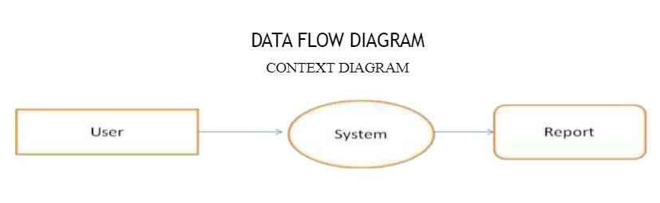

## Table 1

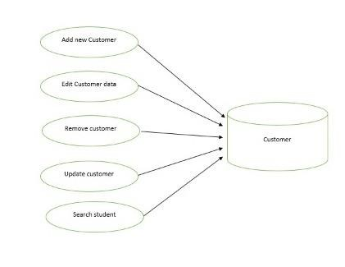

## Used Modul

**1. Administrator:**

Responsible for managing student records.

* Login into the website
* Update student details
* Search student details
* Display student details
* Enable/Disable student

**2**. **Student:** Has the access rights to view and edit their personal details.

* Login into the website
* Display student details
* Edit their details
* Upload their images
* Upload their resumes

# Admin Login Page

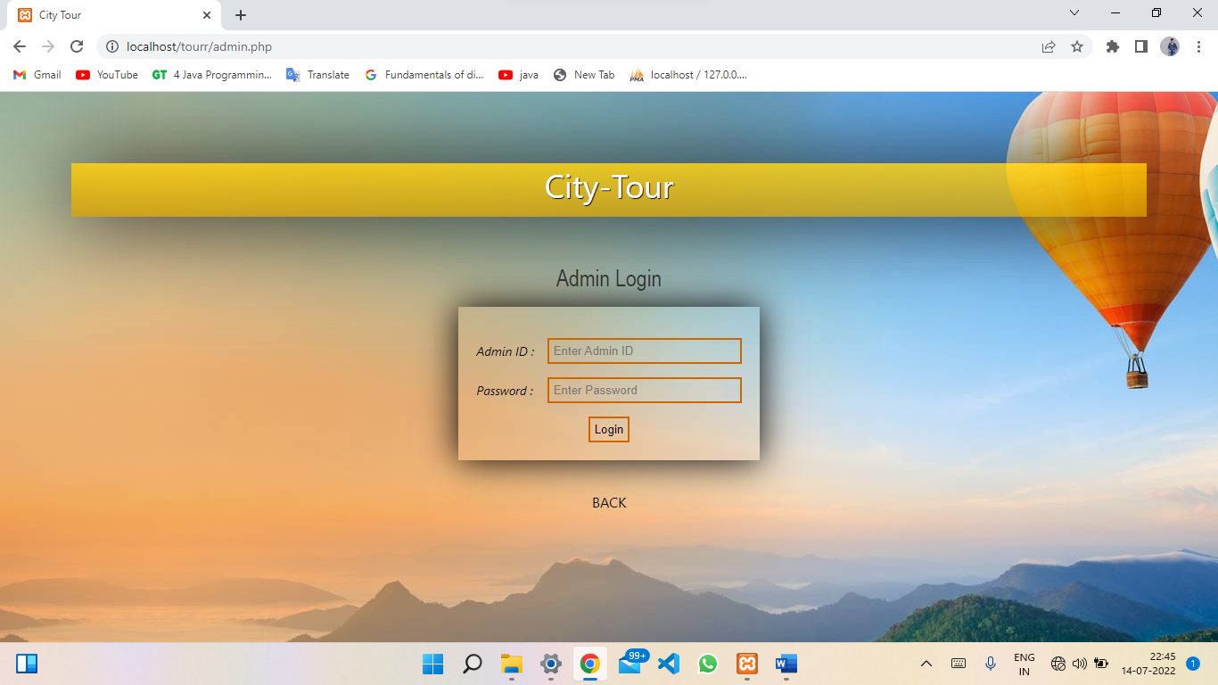

## User Registration Panel

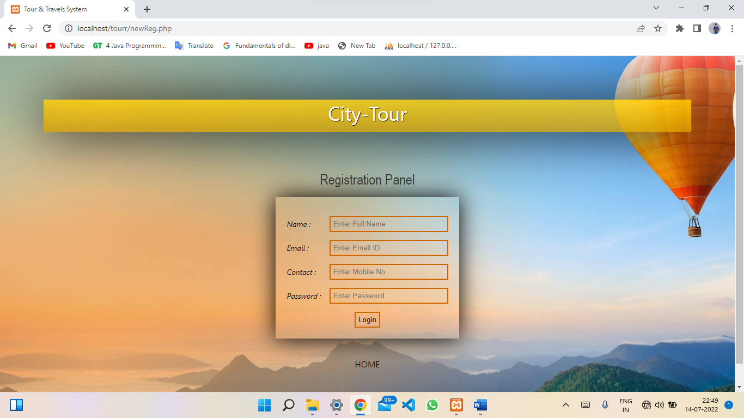

### Admin Page

### 

**Admin Manage Package Page**

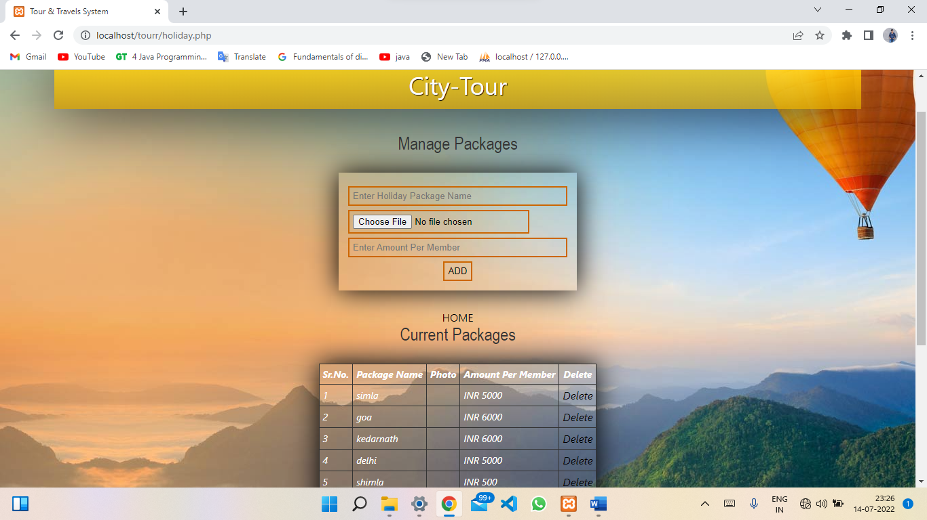

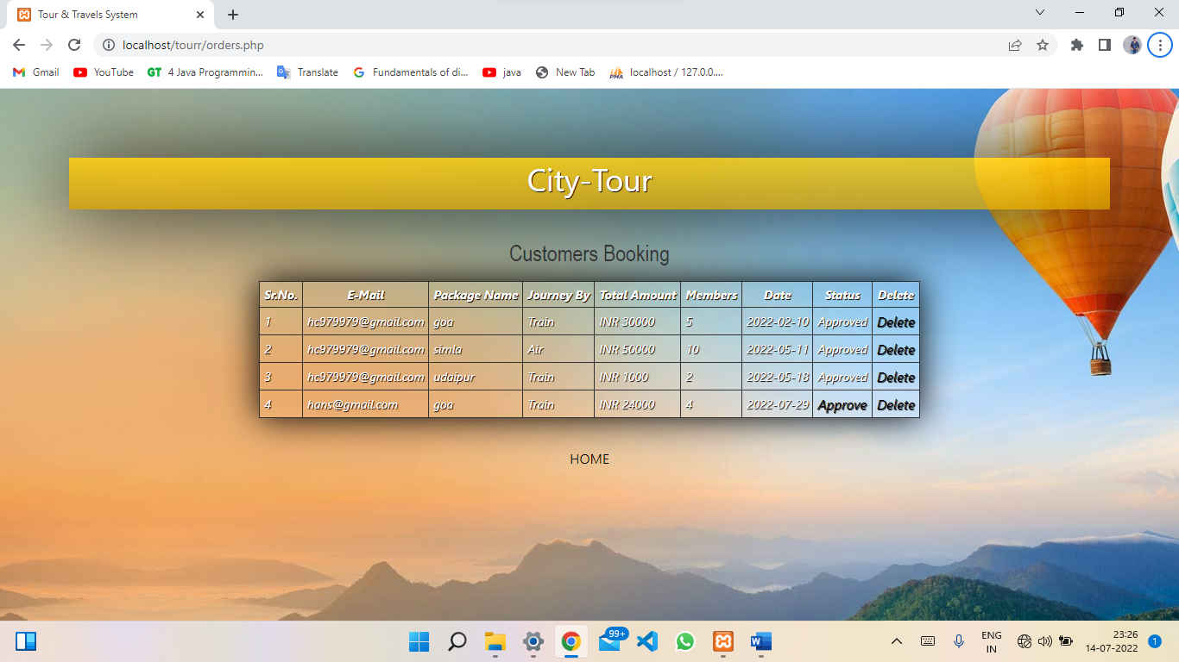 **Admin Orders page**

### Data Base Of Login Page

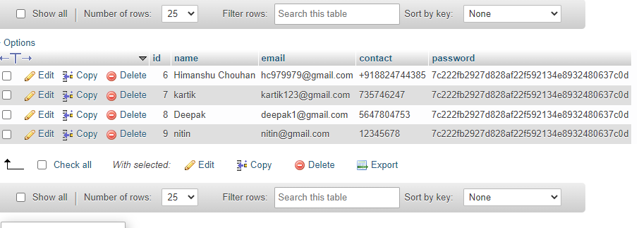

#### Database Of Admin Registration

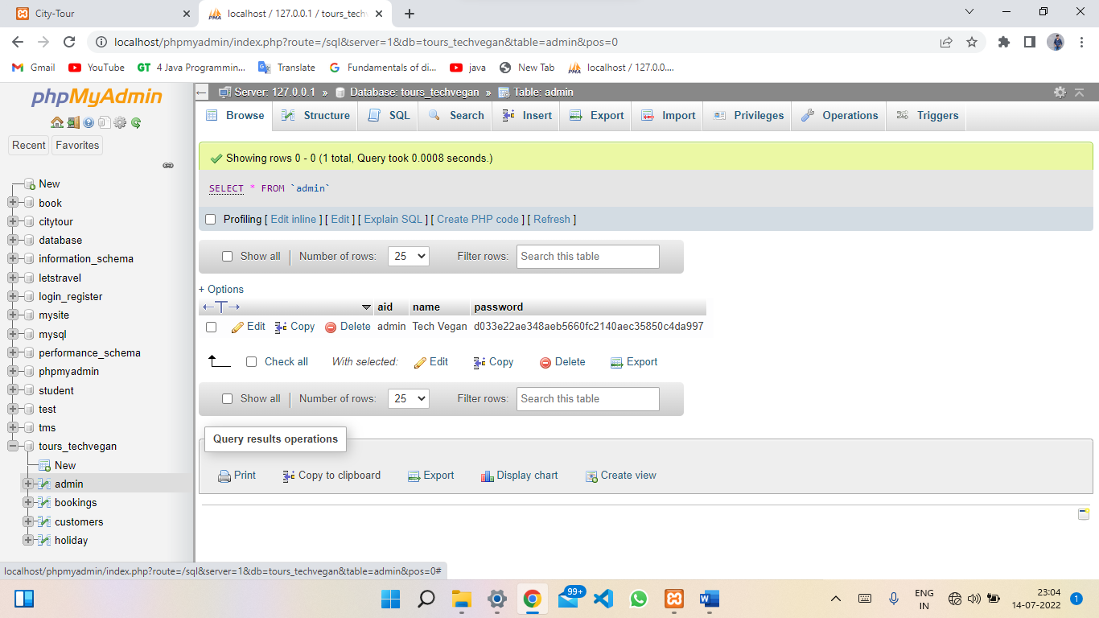

#### Booking Modul

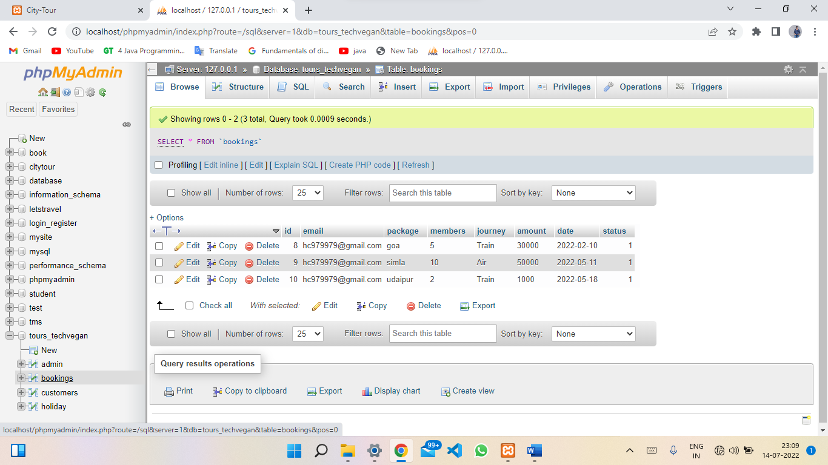

# Front Page Of Web-site

## Booking Page

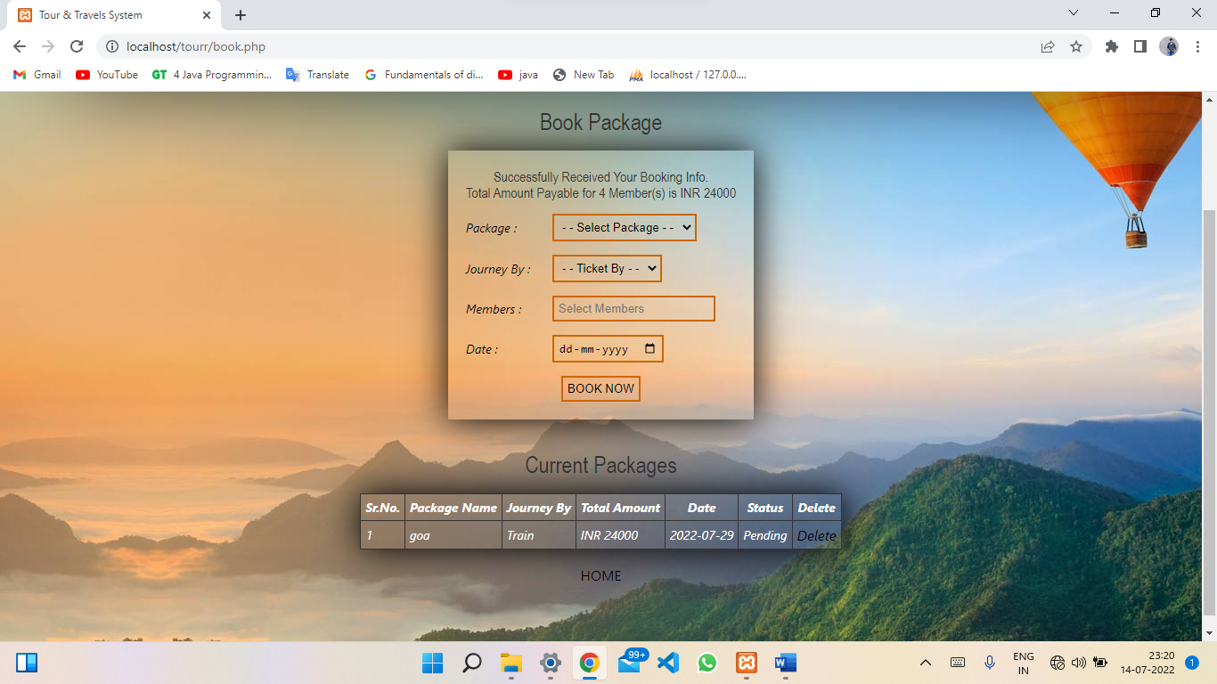

# Scope and purpose

The purpose of the design phase is to develop a clear understanding of what the developer want people to gain from his/her project. As you the developer work on the project, the test for every design decision should be "Does this feature fulfill the ultimate purpose of the project?" A purpose statement affects the design process by explaining what the developer wants the project to do, rather than describing the project itself. The Design Document will verify that the current design meets all of the explicit requirements contained in the system model as well as the implicit requirements desired by the customer.

## Design Phase 1.System Design

### 1.1) Overall System Design Objectives

The overall system design objective is to provide an efficient, modular design that will reduce the system’s complexity, facilitate change and result in an easy implementation. This will be accomplished by designing strongly cohesion system with minimal coupling. In addition, this document will provide interface design models that are consistent user friendly and will provide straight forward transition through the various system functions.

## 1.2) Structure of Design Document

* System Architecture Design – The System architecture section has detailed diagram of the system, server and client architecture.
* Data Design – The data Design include an ERD as well as Database design.
* Functional Design Description – This section has the functional partitioning from the SRS, and goes into great detail to describe each function.

### 2. System Architecture Design

#### 2.1) System Architecture

The SIMS is a system which contain major part which include: house Detail, houses image and price. The user selects one of the available options as an input to the system. According to the input by the user the system acts and the rest of the functions are performed accordingly. The But the normal student or users can only access administartor can operate on any student details.

their details of all the functionalities

## 3. Data Design

**3.1) Entity Relationship Diagram**:

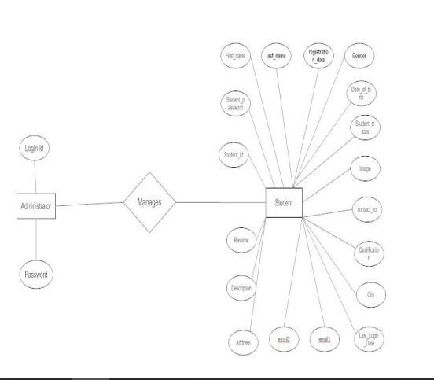**House**

### Entity Relationship Diagram

**4. Functional Design Description 4.1 Data Flow Diagram :**

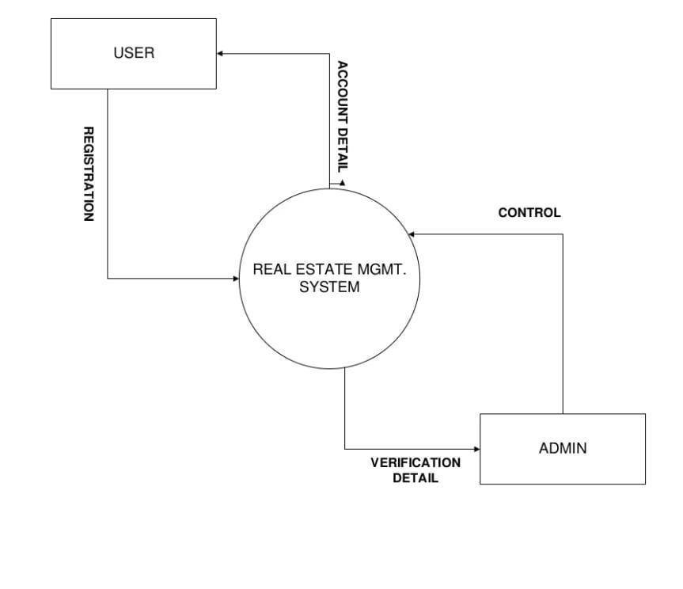

# 5. Conclusion

Hence we can conclude that the design phase of the SIMS give us the information of all the processes used in the project and their relation

## Creating a Database and Inserting Data

Now that we have run and tested Apache and PHP, the next step is running MySQL and creating a database and table which will hold information to be used by our website. In order to start MySQL, navigate to the xampp directory and run the mysql_start.bat batch file.The XAMPP package contains an application called phpMyAdmin which allows developers to administer and maintain MySQL databases.We will be using phpMyAdmin to create a database and table, and enter test data. Before testing phpMyAdmin, make sure that both Apache and MySQL are running by opening their respective batch files: apache_start.bat and mysql_start.bat. Along with Apache and MySQL running in the background, we type http://localhost/phpMyAdmin/ into our web browser. If successful we will be presented with a phpMyAdmin start page similar to the one shown below.

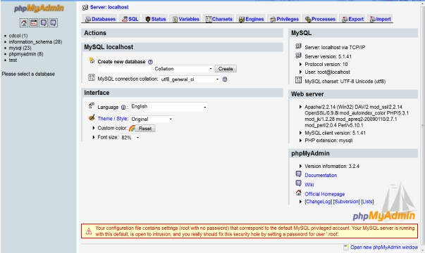

## phpMyAdmin start page

The first step with phpMyAdmin running is creating a new database.We create a new database by directly executing SQL statements as shown below.The successful execution of the sql querry creates a database house with two tables in it.The tabels are admin_login and evernest information.We also inserted values in the admin table.The screenshot below shows the successful execution of the query thus creation of a database named student.

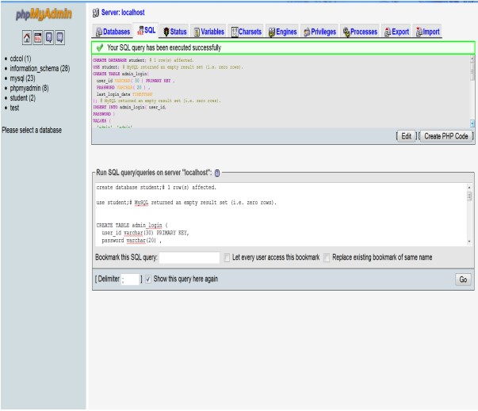

**Creation of database in mysql using phpMyadmin**

Thus we have learned to create a database in creating the database and tables we are now MYSQL by executing sql statements. After

ready to use them in our website “Houseselling ”

## Bibliography

* PHP book by Vasvani (TMH publications).
* Beginning PHP5 by WROX.
* [www.google.com.](http://www.google.com/)
* [www.wikipedia.com](http://www.wikipedia.com/)
* [www.w3schools.com](http://www.w3schools.com/)
* Informatics practices by Sumita Arora.
* Head First PHP & MySQL by Lynn Beighley and

Michael Morrison(O’Reilly)